HTML and CSS Notes for self use

**The basic layout of HTML is as given:**

<html lang="en">

<head>

    <meta charset="UTF-8">

    <meta name="viewport" content="width=device-width, initial-scale=1.0">

    <title>Document</title>

</head>

<body>

</body>

</html>

**Inserting a video in a HTML page**:

<html lang="en">

<head>

    <meta charset="UTF-8">

    <meta name="viewport" content="width=device-width, initial-scale=1.0">

    <title>Document</title>

</head>

<body>

    <video src="A.mp4" controls></video>

</body>

</html>

(Here A.mp4 is a video file in the same file as that of the .html file)

**Inserting JavaScript and Css files in a HTML file**

<html lang="en">

<head>

    <meta charset="UTF-8">

    <meta name="viewport" content="width=device-width, initial-scale=1.0">

    <link rel="stylesheet" href="style.css">

</head>

<body>

    This is my first website. I dont really know jackshit about all this, yet

    <script src="script.js"></script>

</body>

</html>

Here,

<link rel="stylesheet" href="style.css"> Is linking the css file to the HTML and ,

<script src="script.js"></script> is linking the script.js file to the HTML page

**Headers in HTML:**

1. <html lang="en">
2. <head>
3. <meta charset="UTF-8">
4. <meta name="viewport" content="width=device-width, initial-scale=1.0">
5. <title>Document</title>
6. </head>
7. <body>
8. <h1>My bookmarks - Smayan Kulkarni</h1>
9. <h2>Main Bookmarks - Smayan Kulkarni
10. can be used like this
11. </h2>
12. <h3>Main Bookmarks - Smayan Kulkarni</h3>
13. <h4>Main Bookmarks - Smayan Kulkarni</h4>
14. <h5>Main Bookmarks - Smayan Kulkarni
15. can be used like this too
16. </h5>
17. <h6>Main Bookmarks - Smayan Kulkarni</h6>
18. <p></p>
20. </body>
21. </html>

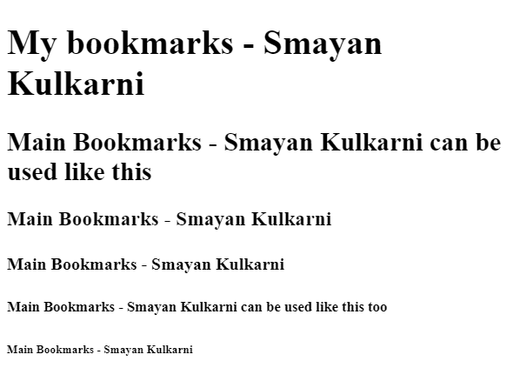

* **The fucntion of “\n” is done by <br>**
* **<sup> for super script: ex: <sup> this</sup> will show: this**
* **<sub> for subscript : ex <h1> I like H<sub>2</sub>o</h1> will show: I like H2O**

**Adding an Image, making a table and making a List in a HTML page:**

</head>

<body>

    <img width= "230" src="train.jpg" alt="Train Image">

    <br>

    <table>

        <thead>

        <tr>

            <th> Name </th>

            <th> Age </th>

            <th> Designation </th>

        </thead>

        <tbody>

        </tr>

        <tr>

            <td> Smayan</td>

            <td > 17</td>

            <td rowspan= "2"> Student</td>

        </tr>

        <tr>

            <td colspan= "2"> Shriayns</td>

        </tr>

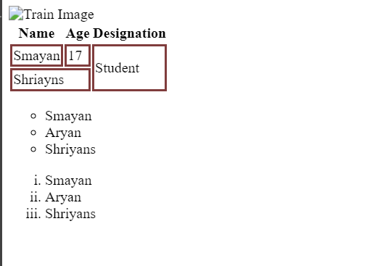    </tbody>

    </table>

    <ul type = "Circle">

        <li> Smayan</li>

        <li> Aryan</li>

        <li> Shriyans</li>

    </ul>

    <ol type = "i">

        <li> Smayan</li>

        <li> Aryan</li>

        <li> Shriyans</li>

    </ol>

</body>

</html>

**Here the css file is:**

td{

    border : 3px solid rgb(128, 61, 61)

}

**Inline and Block Elements:**

<html lang="en">

<head>

    <meta charset="UTF-8">

    <meta name="viewport" content="width=device-width, initial-scale=1.0">

    <title>Inline and Block Elements</title>

    <link rel="stylesheet" href="style.css">

</head>

<body>

    <p> This is a para which is a block element</p>

    <a href="https://google.com">google</a>

    <div>Div is a block element and is not inline</div>

    <span>This is a span which is an inline element</span>

    <a href="">yes it is inline</a>

</body>

</html>

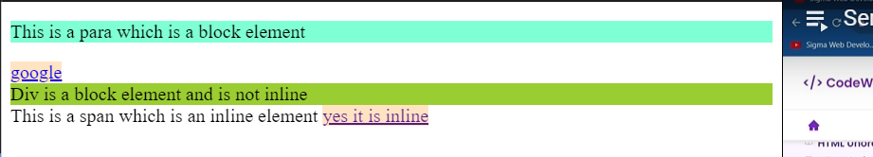

The CSS file was :

p{

    background-color: aquamarine;

}

a{

    background-color: bisque;

}

div{

    background-color: yellowgreen;

}

**ID and classes**

<html lang="en">

<head>

    <meta charset="UTF-8">

    <meta name="viewport" content="width= , initial-scale=1.0">

    <title>ID and Classes </title>

    <link rel="stylesheet" href="style.css">

</head>

<body>

    <div id="firstdiv" class="red bg-yellow">First</div>

    <div if="seconddiv">Second</div>

</body>

</html>



**Video, Audio and Media**

<html lang="en">

<head>

    <meta charset="UTF-8">

    <meta name="viewport" content="width=device-width, initial-scale=1.0">

    <title>Audio, video and media</title>

</head>

<body>

    <video src="video.mp4"controls width="445px" height="455" loop autoplay poster="download.png"></video>

    <audio src="Michishirube English.mp3" controls autoplay></audio>

    <iframe width="560" height="315" src="https://www.youtube.com/embed/GMGj8Izredg?si=K176SNEwzOWFvwEN" title="YouTube video player" frameborder="0" allow="accelerometer; autoplay; clipboard-write; encrypted-media; gyroscope; picture-in-picture; web-share" allowfullscreen></iframe>

    <iframe style="border-radius:20px" src="https://open.spotify.com/embed/track/57o7RdOWikFpIlhYP3G4tj?utm_source=generator" width="250" height="152" frameBorder="0" allowfullscreen="" allow="autoplay; clipboard-write; encrypted-media; fullscreen; picture-in-picture" loading="lazy"></iframe>

</html>

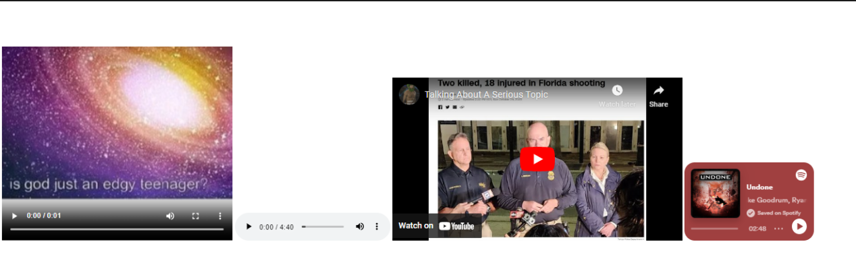

**HTML Semantic Tags**

Semantic tags add meaning to your HTML. They tell both the browser and the developer what kind of content is being presented.

Here are some of the key semantic tags you must know about:

1. <header>: Used to represent the top section of a web page, often containing headings, logos, and navigation.
2. <nav>: Signifies a navigation menu on a web page.
3. <article>: Indicates a self-contained piece of content, such as a blog post or news article.
4. <section>: Represents a thematic grouping of content on a web page.
5. <aside>: Typically used for sidebars or content that is tangentially related to the main content.
6. <footer>: Represents the footer of a web page, usually containing copyright information and contact details.
7. <figure> and <figcaption>: Used for embedding images, diagrams, or charts, along with a caption.
8. <main>: Signifies the main content area of a web page.
9. 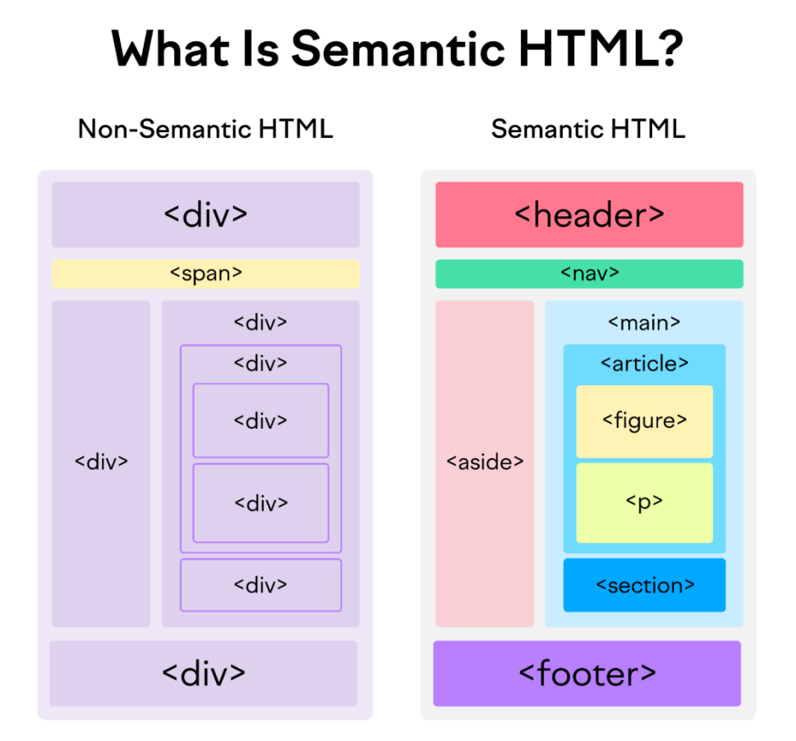<time>: Used to represent time-related information, like dates and times.

CSS

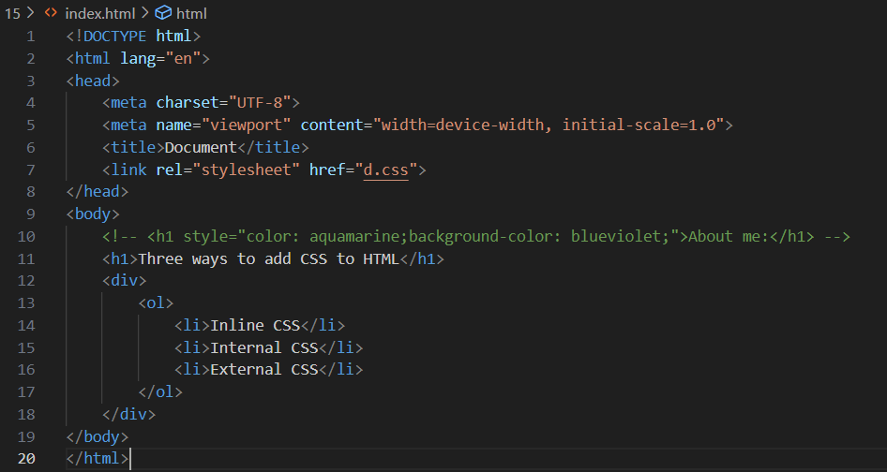

**Types of CSS:**

1. **Inline CSS**
2. **Internal CSS**
3. **External CSS**

**CSS Selectors:**

<head>

    <meta charset="UTF-8">

    <meta name="viewport" content="width=device-width, initial-scale=1.0">

    <title>CSS Selectors</title>

    <style>

      /* Descendant Selector */

    div p{

            background-color: brown !important;}

    /* Class Selector */

    .red{

        background-color: aqua;}

    /* ID selector  */

    #green{

        background-color: green;}

    /* Universal Selector */

    *{

        margin: 0;

        padding: 0;}

    /* Psuedo Selectors*/

    a:visited{

        color: yellow;}

    a:link{

        color: aliceblue;}

    a:active{

        color: blueviolet;}

    a:hover{

        background-color: indianred;}

    p:first-child{

        background-color: darkgoldenrod;}

    </style>

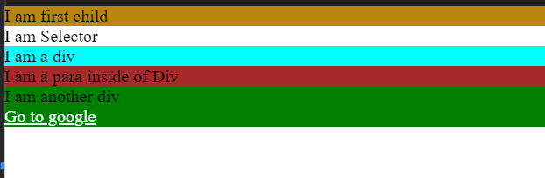</head>

<body>

    <main>

        <p>

            I am first child

        </p>

    </main>

    <div class="selector">

        I am Selector

    </div>

    <div class="red">

        I am a div

        <p>I am a para inside of Div</p>

    </div>

    <div id="green">

        I am another div

        <div>

            <a href="https://google.com">Go to google</a>

            <a href="https://facebook2.com"></a>

        </div>

    </div>

</body>

</html>

**Emmet Shortcuts**:

[Emmet Cheatsheet](https://drive.google.com/file/d/1Zvl_e1DOc_GJI-vSC633Bwd68_pqTOZC/view?usp=sharing)

**Forms in HTML:**

<head>

    <meta charset="UTF-8">

    <meta name="viewport" content="width=device-width, initial-scale=1.0">

    <title>Forms</title>

</head>

<body>

    <h1>Form Demo:</h1>

    <form action="">

        <input type="text" placeholder="Enter your name" id="Namebar">

        <input type="password" placeholder="Enter your password" id="passbar">

        <input type="color">

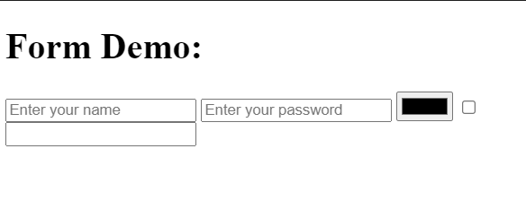        <input type="checkbox">

        <input type="email">

    </form>

</body>

</html>

[All types of forms](https://developer.mozilla.org/en-US/docs/Web/HTML/Element/input)

**Labels for Inputs:**

<head>

    <meta charset="UTF-8">

    <meta name="viewport" content="width=device-width, initial-scale=1.0">

    <title>Labels and Names</title>

</head>

<body>

    <form action="/this-project">

        <p>

            <label for="username">Enter a username</label>

            <input type="text" name="username" id="username" placeholder="Enter your username">

        </p>

        <p>

            <label for="password">Enter your password</label>

            <input type="password" id="password" name="password" placeholder="password">

        </p>

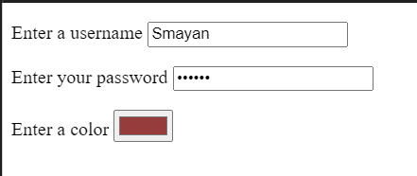        <p>

            <label for="color">Enter a color</label>

            <input type="color" id="color" name="color">

        </p>

    </form>

</body>

</html>

**Radio Buttons, List, Range Inputs and Text Area:**

<head>

    <meta charset="UTF-8">

    <meta name="viewport" content="width=device-width, initial-scale=1.0">

    <title>Other inputs</title>

</head>

<body>

    <h2>More inputs!</h2>

    <form action="/forms.html" >

        <input type="checkbox" name="agree_tos" id="agree">

        <label for="agree">I agree to everything </label>

        <p>

            <input type="radio" name="opt" id="S"v  value="small size shirt">

            <label for="S">Small</label>

            <input type="radio" name="opt" id="M" value="medium size shirt">

            <label for="M">Medium</label>

            <input type="radio" name="opt" id="L" value="large size shirt">

            <label for="L">Large</label>

        </p>

        <p>

            <label for="">Please select an Entree</label>

            <select name="mean" id="mean">

                <option value="Fish">Fish</option>

                <option value="Veg" selected> Vegetarian</option>

                <option value="Chicken">Chicken</option>

            </select>

        </p>

        <p>

            <label for="cheese">Amount of Cheese:</label>

            <input type="range" id="cheese" min="1" max ="100" name="cheese_level">

        </p>

        <p>

            <label for="req">Any special requests?</label>

            <textarea name="spl_req" id="req" cols="40" rows="15" placeholder="enter whatever special requests you have in here!"></textarea>

        </p>

        <button>Submit!</button>

    </form>

</body>

</html>

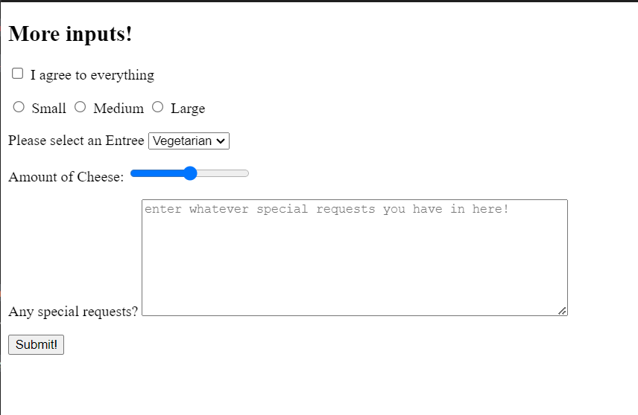

**Fonts in CSS:**

h1{

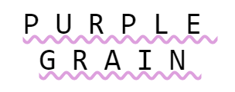    font-family: monospace;

    text-transform: uppercase;

    text-align: center;

    font-weight: 100;

   font-size: 40px;

   text-decoration: underline plum wavy;

    letter-spacing: 20px;

}

**Font Managing in CSS:**

**Ex 9:**

**HTML:**

<head>

    <meta charset="UTF-8">

    <meta name="viewport" content="width=device-width, initial-scale=1.0">

    <title>Document</title>

    <link rel="stylesheet" href="style.css">

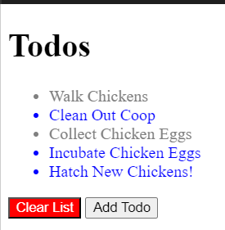</head>

<body>

    <h1>Todos</h1>

<ul>

  <li class="done">Walk Chickens</li>

  <li>Clean Out Coop</li>

  <li class="done">Collect Chicken Eggs</li>

  <li>Incubate Chicken Eggs</li>

  <li>Hatch New Chickens!</li>

</ul>

<button id="clear">Clear List</button>

<button>Add Todo</button>

</body>

</html>

**CSS**

li{

    color: blue;

}

.done{

    color: grey;

}

#clear{

    background-color: red;

    color: white;

}

**EX 10:**

**HTML:**

<head>

    <meta charset="UTF-8">

    <meta name="viewport" content="width=device-width, initial-scale=1.0">

    <title>Document</title>

    <link rel="stylesheet" href="style.css">

</head>

<body>

<header>

    <a href="/home">Home</a>

    <a href="/contact">Contact</a>

    <a href="/about">About</a>

  </header>

  <p>

    I like to eat <a href="/popcorn">popcorn</a> and <a href="/donuts">donuts</a>

  </p>

  <p id="dislikes">

    I hate eating <a href="/pickles">pickles</a> and <a href="/beets">beets</a>

  </p>

</body>

</html>

**CSS:**

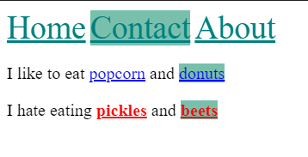header a {

    font-size: 30px;

    color: teal;

}

#dislikes a{

    color: red;

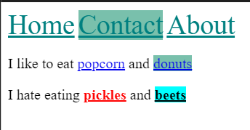    font-weight: bold;

}

a:hover, #dislikes :hover{

    background-color: aqua;

    color: black;

}

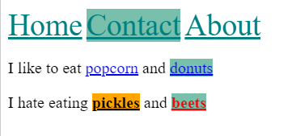a:active{

    background-color: orange !important;

}

a:nth-of-type(2){

    background-color: rgba(86, 176, 150, 0.793);

}

**CSS Specificity:**

Specificity is how the browser decides which rules to apply when multiple rules could apply when multiple rules could apply to the same element.

Usually higher order element selecters have higher selectivity.

Specificity Calculator: **<https://specificity.keegan.st>**

**CSS Box Model;**

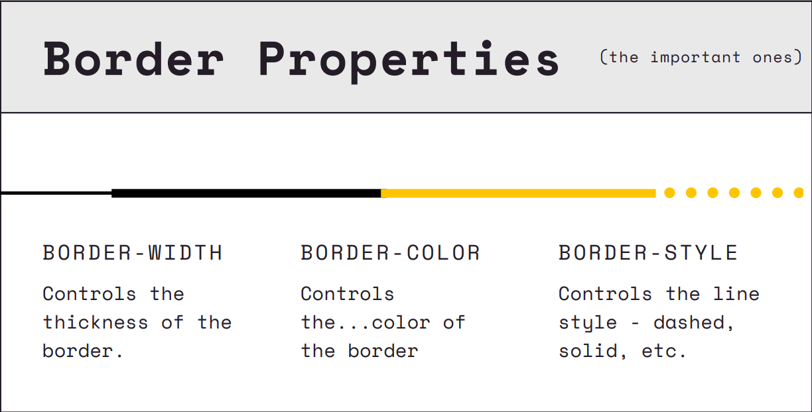

**Padding and Borders:**

**HTML:**

<head>

    <meta charset="UTF-8">

    <meta name="viewport" content="width=device-width, initial-scale=1.0">

    <title>Box Model Demo</title>

    <link rel="stylesheet" href="style.css">

</head>

<body>

    <h1>Hello! <span>:)</span></h1>

    <div id="one">Lorem ipsum dolor sit, amet consectetur adipisicing elit. Impedit magni pariatur, odio voluptates esse

        veniam.

        Quos omnis, necessitatibus beatae architecto sint inventore dicta vero magni. Dicta rem ipsam accusamus atque.

    </div>

    <div id="two">Lorem ipsum dolor sit, amet consectetur adipisicing elit. Impedit magni pariatur, odio voluptates esse

        veniam.

        Quos omnis, necessitatibus beatae architecto sint inventore dicta vero magni. Dicta rem ipsam accusamus atque.

    </div>

    <div id="three">Lorem ipsum dolor sit, amet consectetur adipisicing elit. Impedit magni pariatur, odio voluptates

        esse veniam.

        Quos omnis, necessitatibus beatae architecto sint inventore dicta vero magni. Dicta rem ipsam accusamus atque.

    </div>

    <button>Pad Me!</button>

</body>

</html>

**CSS:**

body {

    margin: 0;

}

div {

    width: 200px;

    height: 200px;

}

span {

    margin-left: 30px;

    margin-top:30px;

}

h1 {

    background-color: pink;

    width: 200px;

    padding-left: 100px;

    padding-top: 50px;

    margin: 0;

}

#one {

    background-color: #e5989b;

    border-width: 5px;

    border-color: black;

    border-style: solid;

    /* box-sizing: border-box; */

    margin-left: 50px;

    margin-bottom: 100px;

}

#two {

    background-color: #b5838d;

    border-color: #ffcdb2;

    border-width: 3px;

    border-style: dashed;

    border-left-width: 8px;

    padding-right: 50px;

    margin: 200px;

}

#three {

    background-color: #6d6875;

    border: 4px solid black;

    border-left-style: dotted;

    border-radius: 50%;

}

button {

    padding: 10px 20px 30px 40px;

}

**IMP:** If an element is displayed inline, width, height is ignored, but padding works, but padding doesn’t push content away and take space on its own, it is ignored by the rest of the content.  
Ex:

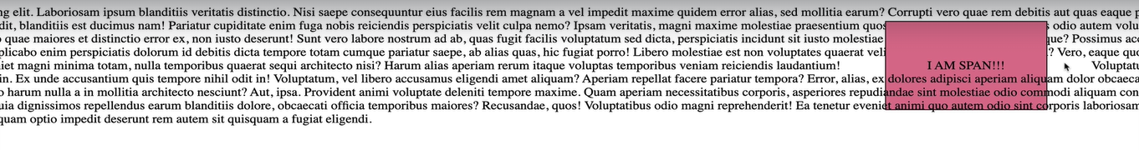

Size Scaling:

Ems: It is a relative unit which takes the relative size of the parent element and then can be used to relatively scale all the other elements inside a parent element.

Ex:

**Opacity:**

**HTML:**

<!DOCTYPE html>

<html lang="en">

<head>

    <meta charset="UTF-8">

    <meta name="viewport" content="width=device-width, initial-scale=1.0">

    <title>Opacity & Alpha</title>

    <link rel="stylesheet" href="app.css">

</head>

<body>

    <section>

        <div id="rgba">

            Lorem ipsum dolor sit amet, consectetur adipisicing elit. Fugiat pariatur dolor doloribus excepturi magni

        </div>

    </section>

    <section>

        <div id="opacity">

            Lorem ipsum dolor sit amet, consectetur adipisicing elit. Fugiat pariatur dolor doloribus excepturi magni

            <button>alksjdlaksjd</button>

        </div>

    </section>

</body>

</html>

**CSS:**

section {

    width: 500px;

    height: 500px;

    background-color: magenta;

}

#rgba {

    width: 50%;

    height: 50%;

    background-color: rgba(255,255,255,0.7)

}

#opacity {

    width: 50%;

    height: 50%;

    background-color: yellow;

    opacity: 0.3;

}

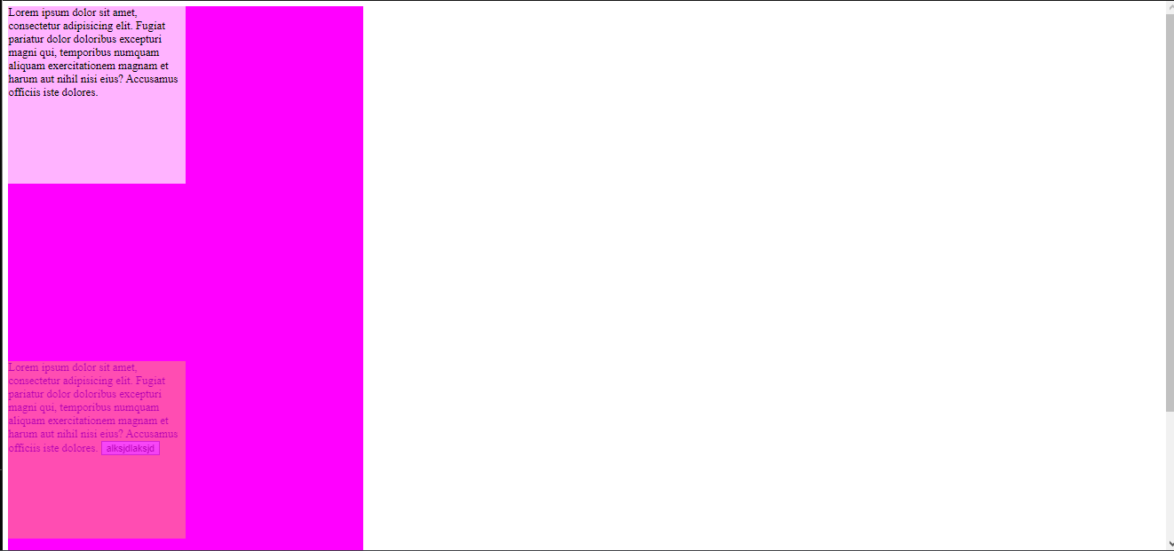

**Positions:**

**HTML:**

<!DOCTYPE html>

<html lang="en">

<head>

    <meta charset="UTF-8">

    <meta name="viewport" content="width=device-width, initial-scale=1.0">

    <title>Position</title>

    <link rel="stylesheet" href="app.css">

</head>

<body>

    <h1>Position Property</h1>

    <section id="static">

        <h2>Static</h2>

        <div></div>

        <div id="middle"></div>

        <div></div>

    </section>

    <section id="relative">

        <h2>Relative</h2>

        <div></div>

        <div id="middle"></div>

        <div></div>

    </section>

    <section id="absolute">

        <h2>Absolute</h2>

        <div></div>

        <div id="middle"></div>

        <div></div>

    </section>

    <section id="fixed">

        <h2>Fixed</h2>

        <div></div>

        <div id="middle"></div>

        <div></div>

    </section>

    <p>Lorem ipsum dolor sit amet consectetur adipisicing elit. Voluptate est, corporis nesciunt distinctio accusantium

        voluptatum itaque, vel veritatis minima ab autem laudantium voluptates cum commodi maiores tenetur obcaecati

        sint at?

        Aspernatur hic reprehenderit quam dolorem tempore cupiditate ut necessitatibus veritatis aperiam esse, nulla

        laboriosam nobis dolore atque velit nostrum, magnam in ipsa iure aut officia amet labore quos. Nesciunt,

        voluptatum?

</body>\

</html>

**CSS:**

div {

    width: 100px;

    height: 100px;

    background-color: #3d405b;

    border: 2px solid black;

    margin: 10px;

    display: inline-block;}

#middle {

    background-color: #81b29a;}

#static #middle {

    position: static;

    top: 100px;}

#relative #middle {

    position: relative;

    top: 50px;

    left: 50px;}

#absolute {

    position: relative;}

#absolute #middle {

    position: absolute;

    top: 1px;

    left: 1px;}

#fixed #middle {

    position: fixed;

    top: 0;

    left: 400px;}